**High Level Design (HLD)**

**PRESCRIPTION LABEL READING**

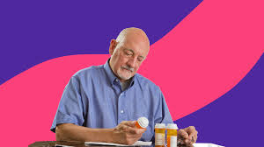

**Revision Number - 1.0**

**Last Date of Revision – 16-11-2023**

**BRILLIABIBIN**

# Document Version Control

|  |  |  |  |
| --- | --- | --- | --- |
| **Date Issued** | **Version** | **Description** | **Author** |
| 16-11-2023 | 1.0 | HLD Document | BrilliaBibin |
|  |  |  |  |
|  |  |  |  |

**Contents**

Document Version Control………………………………………………………………………….2

Abstract……………………………………………………………………………………………….3

1. Introduction……………………………………………………………………………………….4.
2. General Description……………………………………………………………………………...5
   1. Product Perspective & Problem Statement……………………………………….…5
   2. Tools Used……………………………………………………………………………....5
3. Design Detail……………………………………………………………………………………...7
   1. Functional Architecture………………………………………………………………....7
   2. Optimization………………………………………………………………………….….8
4. KPI……………………………………………………………………………………………….…9
5. Deployment……………………………………………………………………………………......9

# Abstract

A Doctor's prescription is a handwritten document written by doctors in the form of instructions that describes list of drugs for patients in time sickness, injuries and other disability problems. While we receiving a new prescription from doctor, it is unable to understand what drug name is prescribed on it. In most cases, however, we wouldn't be able to read it anyway because doctors use Latin abbreviations and medical terminologies on prescriptions that are not understandable by the general persons which make reading it very difficult. According to the National Academy of Sciences estimates that at least 1.5 million peoples are sickened, injured or killed each year by errors while reading prescription.

# 1 Introduction

Reading is essential in today’s world. We see printed text everywhere in our surroundings. In our day to day lives we see newspapers, receipts, slips, menu cards, product packages, wrappers, medicines, reports, medical prescriptions etc. In order to help visually impaired people we have optical aids, video magnifiers, and screen readers which can help visually impaired people and the people with low vision. Braille is a system for reading and writing through touch for visually impaired in which the letters of the alphabet are represented with raised dots. Equivalents for punctuation is also present in braille. The hands are moved from left to right over each line to feel the characters using braille. The visually impaired people can feel printed labels using Braille. There are few devices such as Braille Note Touch Plus, Bluetooth Braille Displays etc. that can provide help to these people to carry out their work easily. There are recent developments in the field of digital cameras, computer vision and portable computers. These developing camera-based products combine various technology with some existing commercial products to make it access the information about the various products.

However a big limitation is that it is very difficult for visually impaired people to find the position of the bar code and to correctly point the bar code reader at the bar code scanner. Some reading systems like pen scanners, mobile readers might be deployed in these similar situations.

OCR software is integrated with these systems to offer scanning and recognition function of text; also some systems may have integrated voice results. However, these kinds of systems perform best with the text images with simple backgrounds, standard fonts, a range of font size and well-organized characters rather than the hand held product packages with various patterns. Most of the OCR software cannot directly handle the images with complex backgrounds. A number of reading assistants systems have been designed specifically for the visually impaired people, but still no existing reading assistant can read text from the complex backgrounds found on many everyday commercial products.

# General Description

## 2.1 Product Perspective & Problem Statement

* Support elderly or vulnerable patients should be a focus for many businesses. This is especially true for those in the health care sector. Enabling voice messages can make it easier for elderly people to understand your message.
* Text-to-Speech can provide peace of mind by empowering you to give better services. For example, you could even send voice messages that read prescription labels.
* This can be a real challenge for anyone with reading difficulties, not to mention the elderly and visually impaired. A talking label, sent straight to your device, makes it easy to know everything about your medication. Dosage info can also be tracked and shared with caregivers.

## 2.2 Tools used

Business Intelligence tools and libraries works such as paddleOCR, paddlepaddle, gTT, Jupyter Notebook, pillow and Python Programming Language are used to build the whole framework.

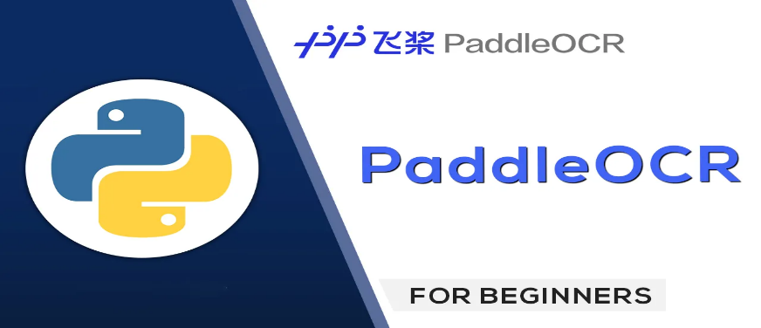

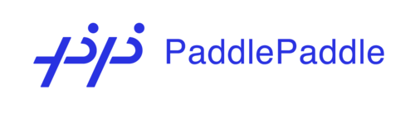







**3 Design Details**

## 3.1 Functional Architecture

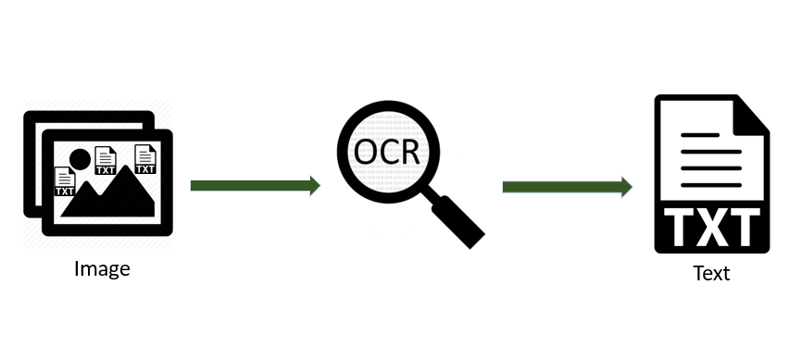

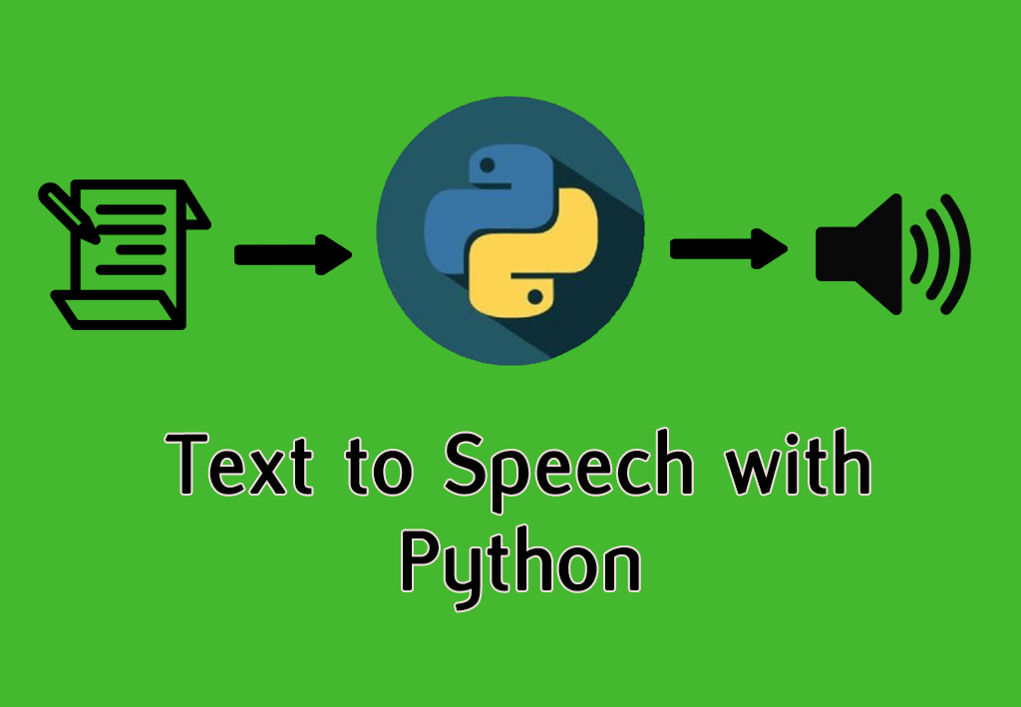

|  |  |
| --- | --- |
|  |  |

HOW MODEL WORKS:

STEP 1: upload an image.

STEP 2: Extracts Text Region.

STEP 3: Extracted text region undergoes text binarization and recognition.

STEP 4: Text recognition is performed by OCR.

STEP 5: Displaying label in the form of text.

STEP 6: Text is converted to speech.

## 3.2 Optimization

#### 1. Your data strategy drives performance

Optimize extracts to speed up future queries by materializing calculations, removing columns and the use of accelerated views

#### 2. Reduce the marks (data points) in your view

* Practice guided analytics. There’s no need to fit everything you plan to show in a single view. Compile related views and connect them with action filters to travel from overview to highly-granular views at the speed of thought.

* Remove unneeded dimensions from the detail shelf.

* Explore. Try displaying your data in different types of views.

# 4 KPI

Output will be implemented to display and indicate certain KPIs and relevant indicators for the image.

As and when the system starts to capture the data for a user, the dashboards will be included to display charts over time with progress on various indicators or factors

# 5 Deployment

Deployment is done in the local system and in Azure portal.